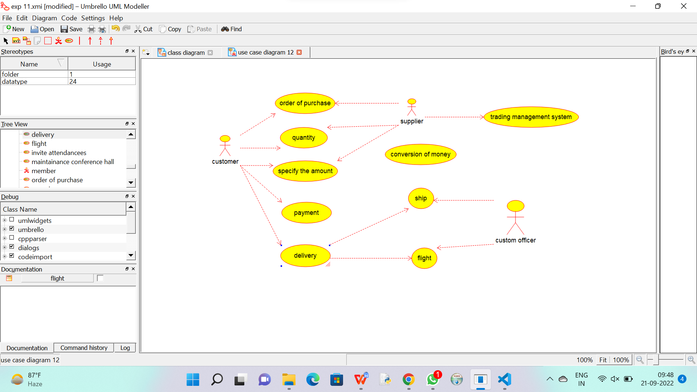

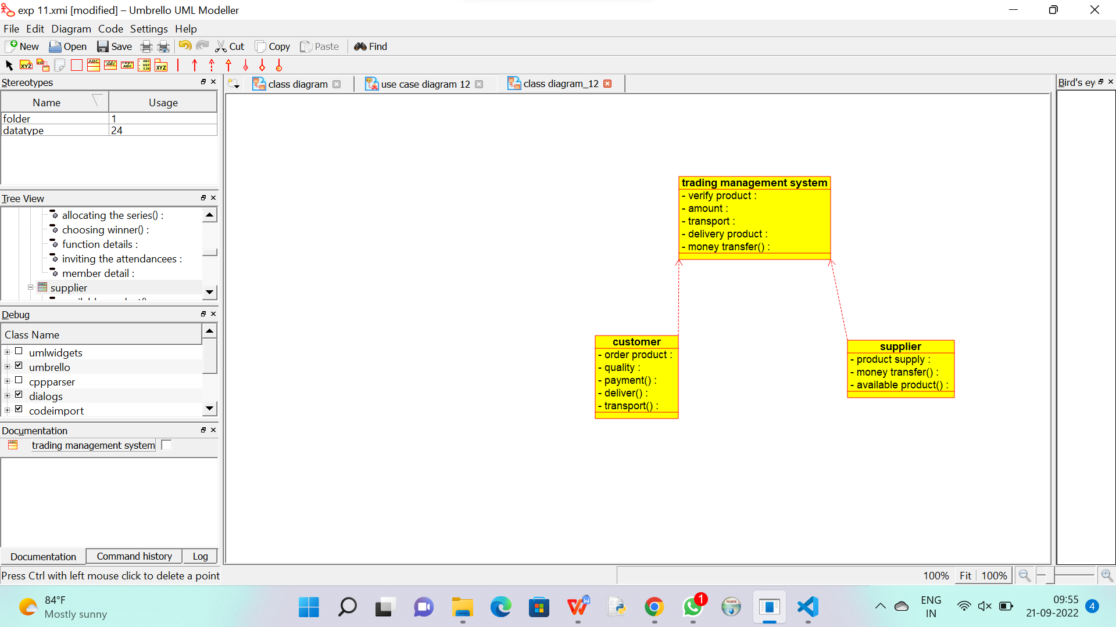

Code generation of trading management system :

/**

 * Class trading_management_system

 */

public class trading_management_system {

  //

  // Fields

  //

  private void verify_product;

  private void amount;

  private void transport;

  private void delivery_product;

  private void money_transfer_;

  //

  // Constructors

  //

  public trading_management_system () { };

  //

  // Methods

  //

  //

  // Accessor methods

  //

  /**

   * Set the value of verify_product

   * @param newVar the new value of verify_product

   */

  private void setVerify_product (void newVar) {

    verify_product = newVar;

  }

  /**

   * Get the value of verify_product

   * @return the value of verify_product

   */

  private void getVerify_product () {

    return verify_product;

  }

  /**

   * Set the value of amount

   * @param newVar the new value of amount

   */

  private void setAmount (void newVar) {

    amount = newVar;

  }

  /**

   * Get the value of amount

   * @return the value of amount

   */

  private void getAmount () {

    return amount;

  }

  /**

   * Set the value of transport

   * @param newVar the new value of transport

   */

  private void setTransport (void newVar) {

    transport = newVar;

  }

  /**

   * Get the value of transport

   * @return the value of transport

   */

  private void getTransport () {

    return transport;

  }

  /**

   * Set the value of delivery_product

   * @param newVar the new value of delivery_product

   */

  private void setDelivery_product (void newVar) {

    delivery_product = newVar;

  }

  /**

   * Get the value of delivery_product

   * @return the value of delivery_product

   */

  private void getDelivery_product () {

    return delivery_product;

  }

  /**

   * Set the value of money_transfer_

   * @param newVar the new value of money_transfer_

   */

  private void setMoney_transfer_ (void newVar) {

    money_transfer_ = newVar;

  }

  /**

   * Get the value of money_transfer_

   * @return the value of money_transfer_

   */

  private void getMoney_transfer_ () {

    return money_transfer_;

  }

  //

  // Other methods

  //

}

Code generation of supplier :

/**

 * Class supplier

 */

public class supplier {

  //

  // Fields

  //

  private void product_supply;

  private void money_transfer_;

  private void available_product_;

  //

  // Constructors

  //

  public supplier () { };

  //

  // Methods

  //

  //

  // Accessor methods

  //

  /**

   * Set the value of product_supply

   * @param newVar the new value of product_supply

   */

  private void setProduct_supply (void newVar) {

    product_supply = newVar;

  }

  /**

   * Get the value of product_supply

   * @return the value of product_supply

   */

  private void getProduct_supply () {

    return product_supply;

  }

  /**

   * Set the value of money_transfer_

   * @param newVar the new value of money_transfer_

   */

  private void setMoney_transfer_ (void newVar) {

    money_transfer_ = newVar;

  }

  /**

   * Get the value of money_transfer_

   * @return the value of money_transfer_

   */

  private void getMoney_transfer_ () {

    return money_transfer_;

  }

  /**

   * Set the value of available_product_

   * @param newVar the new value of available_product_

   */

  private void setAvailable_product_ (void newVar) {

    available_product_ = newVar;

  }

  /**

   * Get the value of available_product_

   * @return the value of available_product_

   */

  private void getAvailable_product_ () {

    return available_product_;

  }

  //

  // Other methods

  //

}

Code generation of customer :

/**

 * Class customer

 */

public class customer {

  //

  // Fields

  //

  private void order_product;

  private void quality;

  private void payment_;

  private void deliver_;

  private void transport_;

  //

  // Constructors

  //

  public customer () { };

  //

  // Methods

  //

  //

  // Accessor methods

  //

  /**

   * Set the value of order_product

   * @param newVar the new value of order_product

   */

  private void setOrder_product (void newVar) {

    order_product = newVar;

  }

  /**

   * Get the value of order_product

   * @return the value of order_product

   */

  private void getOrder_product () {

    return order_product;

  }

  /**

   * Set the value of quality

   * @param newVar the new value of quality

   */

  private void setQuality (void newVar) {

    quality = newVar;

  }

  /**

   * Get the value of quality

   * @return the value of quality

   */

  private void getQuality () {

    return quality;

  }

  /**

   * Set the value of payment_

   * @param newVar the new value of payment_

   */

  private void setPayment_ (void newVar) {

    payment_ = newVar;

  }

  /**

   * Get the value of payment_

   * @return the value of payment_

   */

  private void getPayment_ () {

    return payment_;

  }

  /**

   * Set the value of deliver_

   * @param newVar the new value of deliver_

   */

  private void setDeliver_ (void newVar) {

    deliver_ = newVar;

  }

  /**

   * Get the value of deliver_

   * @return the value of deliver_

   */

  private void getDeliver_ () {

    return deliver_;

  }

  /**

   * Set the value of transport_

   * @param newVar the new value of transport_

   */

  private void setTransport_ (void newVar) {

    transport_ = newVar;

  }

  /**

   * Get the value of transport_

   * @return the value of transport_

   */

  private void getTransport_ () {

    return transport_;

  }

  //

  // Other methods

  //

}